Bacteraemia

“Hi everyone, welcome to the IDIOTS podcast, that’s Infectious Disease Insight Of Two Specialists, I’m Jame, that’s Callum, and we’re going to tell you everything you need to know about Infectious disease, Callum how you doing?”

- Definition of bacteraemia/septicaemia/blood stream infection
- How does bacteraemia occur (immunology)
- Diagnosis
  - When to take blood cultures
  - How to take blood cultures
  - How many blood cultures to take
  - What happens to blood cultures in the laboratory
- Management of bacteraemia
  - PK/PD considerations

* I don’t think we should go into detail about specific pathogens or infection; or even management. Focus on the process of organisms entering the blood steam and the details around blood cultures

Definition of bacteraemia/septicaemia/blood stream infection

Definitions
- Bacteraemia = “the presence of bacteria in the blood”
- Septicaemia = “a systemic disease caused by the spread of microorganisms and their toxins via the circulating blood”
- Sepsis = life threatening organ dysfunction causes by dysregulated host response to infection
- Blood stream infection – includes bacteraemia, also includes fungaemia/viraemia/parasitaemia.

Sepsis is an old medical term which comes from the Greek 'sepsin' meaning 'to make putrid'

Therefore most correct to use bacteraemia +/- sepsis. BSI also correct.

How does bacteraemia occur (immunology)

Initial entry to host: Body surface e.g. skin, mucous membranes, lung, gut. Or any defect in these such as trauma, viscous perforation.
- Traverse epithelium and surface membrane
- Enter tissue
  - Antimicrobial substances e.g. antibodies, complement
  - Local macrophages (histiocytes)
  - Physical tissue barriers, e.g. hydrated gel matrix. Virulence factors aid in entry
- Lymphatic system
  - Conveys microorganisms to lymph nodes with large numbers of phagocytic and immunologic defences
- Invade blood
  - The route to achieving this varies. Some invasive organisms due so in an antagonistic approach; disabling/destroying immune response. Others in an immune evasion approach; usually surviving intracellular
    - Examples intracellular pathogens Listeria Brucella; also EBV or Rubella. Malaria
  - Transient bacteraemia common e.g. when tooth brushing or defecating; but usually filtered out of blood especially in spleen/liver by macrophages
    - Certain organisms adapted to multiple in these cells within the “reticuloendothelial system” e.g. Salmonella typhi, leishmanial donovani, Yellow fever
- Travel to other organs
  - Organism specific; unclear why
- Leave the body
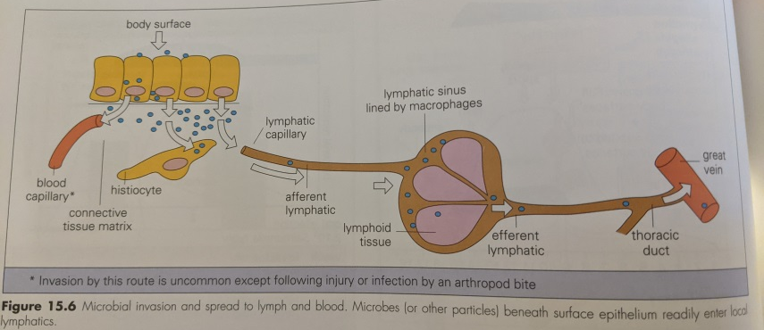
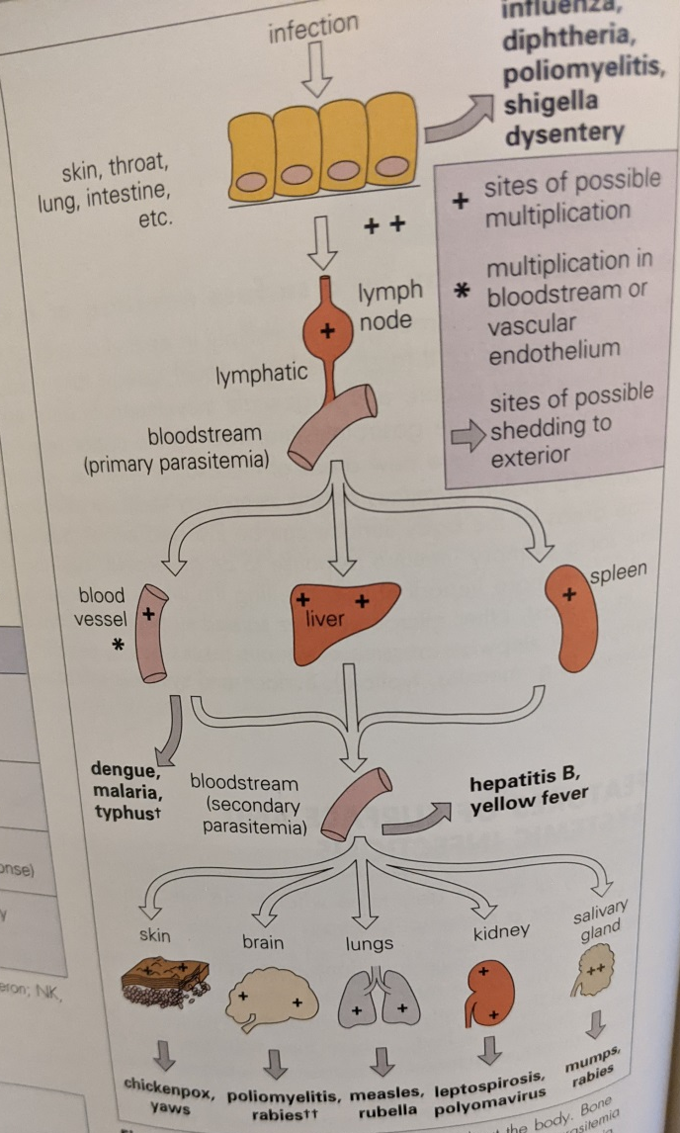

Diagnosis

When to take blood cultures
Anyone who might be bacteraemic
- Not just those who are pyrexia.
- Anyone starting broad spectrum IV antimicrobials in
- Febrile
- Lines
- Especially immunocompromised (may not mount a fever)
- Specific other indications; e.g. typhoid

How to take blood cultures/How many blood cultures to take
- ASNTT
- 10ml per bottle/20 ml total. Volume taken important for sensitivity
- 3 sets>2>1. More sets more sensitive but 3 around ideal cut off vs practically. Different sites
- Timing in relation to fever not important; I.e. don’t wait for the fever; as bacteraemia probably at peak 30 minutes prior
- Limited utility to repeated culturing if on broad spectrum antimicrobials with ongoing fevers having had sets pre-blood cultures; unless acutely deteriorating

What happens to blood cultures in the laboratory

Management of bacteraemia

PK/PD considerations – antimicrobials that are present in blood. High protein binding, low Vd?

IV. high dose.

