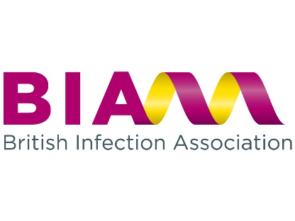
BIA EXPENSES CLAIM FORM

- Claims should be made within 2 months of the date of the event.
- Claims must be reasonable, as economical as possible, and supported by receipts.
- The following have been agreed as suitable for BIA expense claims:

- BIA meeting attendance: travel to and from face-to-face meetings, and one night’s accommodation (max £175). Travel should be as economical as possible and preferably booked in advance to obtain the best rates. Advance first class tickets for journeys longer than 2 hours may be reimbursed if they are cheaper than a standard economy ticket bought at the same time/day of travel. Meetings include Council Meetings, Clinical Services Meetings, and other meetings where BIA representation is required.
- Chairs and speakers for BIA conferences: complementary conference registration.
- Other: at the discretion of Council with prior agreement.

Name:…Amy Read………………………………………………………………………..

Address:………………………………………………………………………………………..

Bank Account sort code ………………. Bank Account Number ……………....................

Claim details (please indicate) | Event Date | x
Society meeting representation
BIA council meeting attendance
Clinical services meeting attendance
Other (please specify) | Conference Name HERE

Expenses details:
Travel | Air | £
Travel | Rail | £
Travel | Taxi | £
Travel | Car | £
Travel | Car Parking | £
Travel | Mileage @ 56p per mile | £
Travel | Other – Trainees Day Prize £100.00 | £100.00
Travel | Sub total | £
Accommodation | Hotel (max £175 per night) | £
 | Total claim amount | £100.00

Signature: ………………………………….. ………………… Date: ……………………….

Please return completed forms to admin@britishinfection.org
BIA, Fitwise Management Ltd, Blackburn House, Redhouse Road, Seafield, Bathgate, EH47 7AQ

