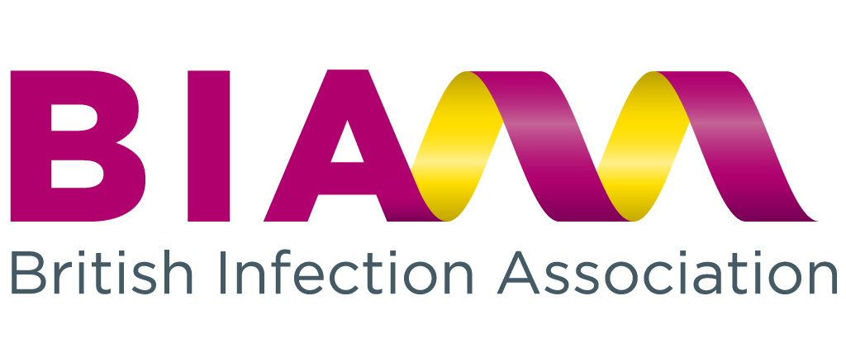

(ISSUED)
British Infection Association Annual Report

Financial Year Ending 30th September 2013
Abbreviations used throughout this review

AMM Association of Medical Microbiologists
BASHH British Association for Sexual Health & HIV
BHIVA British HIV Association
BIA British Infection Association
BIS British Infection Society
BSAC British Society for Antimicrobial Chemotherapy
BSMM British Society for Medical Mycology
CCT Certificate of Completion of Training
DH Department of Health
EAAD European Antibiotic Awareness Day
FIS Federation of Infection Societies
HIS Healthcare Infection Society
HPA Health Protection Agency
IPS Infection Prevention Society
MRC Medical Research Council
NICE National Institute for Clinical Excellence
PMETB Postgraduate Medical Training Board
RCPath Royal College of Pathologists
RCP Royal College of Physicians
SGM Society for General Microbiology

Contents
Contents 2
BIA Council Members 3
Aims & Objectives 4
Membership & Communications 5
Standard Setting & Guideline Development 6
Clinical Services 7
Education & Meetings 8
Manpower & Training 9
Journal of Infection Editor’s Report 10
Annual Trainees’ Report 11
Science & Research 12
Governance & Finance 13
Honorary Treasurer’s Report 14
Honorary Secretary’s Report 17
Contact details 18

BIA Council Members

British Infection Association Council 2013

President* Dr Peter Moss (Hull and East Yorkshire Acute Hospitals NHS Trust)
Vice President* Dr Martin Wiselka (University Hospitals of Leicester NHS Trust)
Interim Honorary Secretary* Dr Albert Mifsud (Whipps Cross University Hospital)
Honorary Treasurer* Dr Stephen Barrett (Southend University Hospital NHS Foundation Trust)
Meetings Secretary* Professor Steve Green (Sheffield Teaching Hospitals NHS Foundation Trust)
Manpower & Training Secretary Dr Albert Mifsud (Whipps Cross University Hospital)
Interim Scientific & Research Secretaries Drs Martin Llewelyn and Melanie Newport (Brighton and Sussex University Hospitals NHS Trust)
Guidelines Secretary Dr Peter Cowling (Northern Lincolnshire & Goole Hospitals NHS Trust)
Membership Secretary Dr David Partridge (Sheffield Teaching Hospitals NHS Foundation Trust)
Clinical Services Secretary (Microbiology) Dr Tony Elston (Colchester Hospital University NHS Foundation Trust)
Clinical Services Secretary (Infectious Diseases) Dr Bridget Atkins (Oxford University Hospitals NHS Trust)
Communications Secretary Dr Kumara Dharmasena (Walsall Hospitals NHS Trust)
Trainee representatives Dr Fiona McGill (University of Liverpool, Leeds Teaching Hospitals NHS Trust)
Dr Thushan De Silva (Sheffield Teaching Hospitals NHS Foundation Trust)
Newsletter Editor Dr Paul Collini (Sheffield Teaching Hospitals NHS Foundation Trust)
Editor, Journal of Infection (ex officio) Professor Rob Read (Sheffield Teaching Hospitals NHS Foundation Trust)

* Principal Officers of the Association

Aims & Objectives

The constitution states that the objective of the Association is to ensure the optimum delivery of healthcare to patients diagnosed with infection.
The British Infection Association aims to enable the best care for patients with infectious disease through:
Supporting high quality clinical and basic science research in the field of infection through competitive award of funding to research applicants,
Setting & reviewing standards in infection practice, including the development of guidelines,
Providing excellent education in infection through meetings and presentations (alone and in collaboration with other scientific societies),
Working with government, Public Health England, NHS England, and other interested bodies to promote best practice in areas related to infectious disease,
Providing expert opinion on infection related matters to external agencies, patients, and the wider public,
Supporting infection specialists within their daily work by facilitating communication and providing useful resources,
Disseminating new research and best practice via the Association’s publication: the Journal of Infection.

Membership & Communications

Dr Kumara Dharmasena
Dr David Partridge
Dr Paul Collini

Aims:
To ensure that infection specialists and trainees are aware of the association; that membership of it is attractive to them, and that it is responsive to their evolving requirements.

Progress 2013/2014:
BIA Membership Type | July |  | BIA Membership Type | June
BIA Membership Type | 2013 |  |  | 2014
Associate - Free | 39 |  | Associate - Free | 28
Full | 784 |  | Full | 659
Overseas | 15 |  | Overseas | 9
Retired | 47 |  | Retired | 42
Trainee | 592 |  | Trainee | 612
Lapsed | 45 |  | Update requested | 79
Grand Total | 1522 |  | Lapsed - No Current email | 51
 |  |  | Grand Total | 1480

Membership Survey:
Earlier this year the membership was surveyed about all aspects of the association’s work. Many thanks to all those who completed the survey – we received 118 responses to it with very valid and useful free text suggestions about how the work of the association could be improved. The results will be published in the next edition of the newsletter. Reassuringly the vast majority of members were satisfied that their membership represented good value for money and that the meetings met their requirements. Areas for development include communication with the membership about research grant outcomes and improvement in the layout and content of the website.
A large number of suggestions for future guidelines was submitted and these will contribute to decisions about which guidelines will be a priority for the association to be involved in the development of over the next couple of years.

New website:
In 2013/14 lot of time and effort went in to development of the new state of the art website for the Association. Among the new features include seamless access to the journal of infection, secure areas for holding and updating membership details and online conference registration and payment of membership subscriptions. The new website design has been informed by the Membership survey and will hopefully be up and running by the end of the year.

Plan 2014/15:
To fully discuss and act upon the results of the membership survey.
To implement a new website.

Standard Setting & Guideline Development

Dr Peter Cowling

Aims:
To support infection practitioners through the development of appropriate guidelines and relevant standards of practice.

BIA involvement in Guidelines published in 2013-14:
BIA has had significant involvement in the production of the following guidelines:
NICE
Seronegative arthritides (draft scope)
Drug allergies
Antibiotics in neonatal infections (Quality Standard)
Hepatitis B
Urinary tract infection in children
Cholelithiasis and cholecystitis
Other Bodies
Standardised Microbiology Investigations and Syndromic Algorithms (various consultations for SMI Working Groups)
EPIC 3

Guidelines currently in preparation:
BIA Meningitis Guidelines
Also, jointly with others:
Bone & Joint Infections Guidelines (Infection Prevention & Control)
Toxigenic Staphylococcal Infections
DH MRSA Screening Policy
We have also met with BSAC, HIS and IPS and agreed to work together on NICE accredited revised MRSA guidelines with a view to establishing a permanent NICE accredited guidelines production system.

Clinical Services
Dr Tony Elston
Dr Bridget Atkins

Aims:
To support infection specialists in their daily work, addressing issues of current concern and importance in the delivery of clinical microbiology, infectious diseases and other infection-related clinical specialties, public health and infection control.

Progress during 2013-14:
Responding to key consultation documents
Contributing to debate and organisational responses at College sub-specialty meetings
Utilisation of the BIA email discussion forum to support members in their daily clinical practice

Microbiology
Dr Tony Elston
Continuing work undertaken for the Royal College of Pathologists ‘Blue Skies Agenda’ to further refine a service specification for infection services
The major topics of discussion have been the transformation of pathology, the evolving infection curriculum, KPIs for microbiology laboratories and a variety of infection prevention and control topics. The committee also exchanges information about regional education and audit meetings.

Infectious Diseases:
Dr Bridget Atkins
Continuing involvement with commissioning of ID services (including the complex bone and joint infection service specification)
Work with Royal College of Physicians consultant workforce census dept, facilitating collection, interpretation and feedback to BIA and others.
On-going major involvement in combined infection training, as a member of specialist training committees for the Royal College of Pathologists and the Royal College of Physicians.
.

Education & Meetings

Steve Green

Aims:
To organise and promote scientific meetings on behalf of the Association (alone, or in collaboration with other scientific bodies) to disseminate knowledge in infection disciplines
To provide a forum for the presentation of clinical and basic science research by clinical academics, including those in training
To award prizes for outstanding presentations, encouraging the production of high quality material.

Highlights from 2013-14:
BIA Spring Scientific meeting held in London, 16th May 2013
Attendance 169
Prizes for best presentations awarded to:
Free Papers: Thushan de Silva (Sheffield) & David Eyre (Oxford)
Clinical Lessons: Shara Palanivel
Poster: Shelui Collinson & Ayoma Ratnappuli
Trainees’ scientific meetings held in May and November 2013
15th May meeting at SOAS, see Trainee section for prizes
14th November meeting at The Studio, Birmingham, see Trainee section for prizes
Full BIA participation of FIS 2013 in Birmingham, with supported lectureships including the JD Williams lecture and the Barnett Christie lecture. The programme included sessions covering Biological Weapons and Bioterrorism, Clinical Academic Careers, Current Challenges in Viral Hepatitis, Clinical Lessons and the Clinical Conundrums.
The Barnett Christie award was presented to Dr Dimitra Peppa (University College London) for a talk entitled ‘Natural Killer cells in chronic hepatitis B virus infection: Friend or foe?’

Manpower & Training

Dr Albert Mifsud

Aims:
To provide evidence on the requirements for consultant numbers in infection nationally;
To support trainees in infection specialities and provide ongoing support to members in substantive posts.

Progress during 2013-14:
Contribution to the JRCPTB / RCPath Infection Training Group through membership of the Deliverability Working Group.
Supporting trainees through the uncertain planning and transition phases of the introduction of the proposed curriculum.
Ongoing advice to RCP (London) and RCPath on workforce requirements.
Ongoing contribution to the work of the Medical Microbiology section of UEMS to ensure that the proposed European curriculum is consistent with the predominantly clinical nature of microbiology training in the UK, culminating in adoption of the curriculum by UEMS.
Responses to relevant consultations such as the GMC’s Shape of Training consultation.
Establishment of a joint BIA / RCPath Consultant Microbiologists and Virologists Workload working group with the intention of producing consultant staffing guidance in 2014/15.

Journal of Infection Editor’s Report

Editor in Chief: Robert Read
North American Editor: Robert Atmar
Associate Editors: David Lalloo, Keith Neal, Katie Jeffery, Mark Nelson, David Partridge, Delia Goletti, Tom Harrison, Peter Moss, Martin Wiselka, Dimitrios Kontonyianis,
Editorial Assistant: Laura Harrison

Summary 2014:
Journal of Infection’s latest impact factor (2012) is 4.073 and the Journal retained its position at 15/69 in the ISI Infectious Diseases category.
The quality of papers continues to increase and the overall rejection rate has increased slightly from 82% in 2013 to 83% 2014YTD.
The average time from submission of an article to it appearing online in a citeable format and downloadable is a competitive 17.4 weeks.
Once accepted papers have taken on average 1.6 weeks to appear on Science Direct.
A total of 305,734 papers were downloaded in 2013, an average of 25,478 per month. From Jan-Mar 2014 a total of 89,128 papers have been downloaded, an average of 29,709 per month.
Members can now access the Journal of Infection content via iPad, iPhone and android apps
New Journal initiatives include OA Hybrid option, YPYW, Crossmark, EMPOWER, Audio Slides, Highlights & Graphical abstracts and Google Maps, Article Usage Alerts, Journal Insights and CrossMark.
A full report has been made available to members on request to BIA@hartleytaylor.co.uk;

Annual Trainees’ Report

Dr Fiona McGill
Dr Thushan de Silva

Meeting Highlights from 2013 -14:
Again we had two very successful meetings.
Spring Meeting 2013 – SOAS
Theme: Infections in the Immunocompromised
Case presentation prize winner: Cariad Evans, Sheffield
Autumn Meeting 2013 – Birmingham
Theme: Drug resistance and healthcare associated infection.
Both meetings were well attended and received positive feedback.
In addition the trainee representative continue to represent the trainees in infection specialties on various national committees concerned with training – both current and future.

Science & Research
Dr Martin Llewelyn
Professor Melanie Newport

Highlights from 2013 -14:
A very successful spring meeting was held in May 2013 at which awards totaling £2300 were made for the two best scientific free papers the best clinical case and best poster presentation.
The scientific and research committee made a huge effort to administer and review applications for the round of research funding awards in 2013. As a result the process ran smoothly the association made a total of around £122,000 worth of awards as follows
Two fellowship awards of £50,000 to Dr Tomasz Prajsnar (University of Sheffield) and Dr Anna Goodman (UCL, London).
Four small awards of £5000 and three travel awards were also made.
Eleven strong applications were received to give the Barnet Christie Lecture at the Federation of Infection Societies Meeting 2013. Dr Dimitra Peppa from University College London was selected and gave an excellent talk entitled ‘Natural Killer cells in chronic hepatitis B virus infection: Friend or foe?’
Following a request from the organizers of the Oxford Bone infection Conference 2014 the society provided funds (£300) for two awards made for presentations.
After discussion among the scientific and research committee and with council, changes were made to the funding available for research in 2014 as follows.
A three-year BIA/MRC Clinical Research Training Fellowship will be available through the infection and immunity board September 2014 deadline.
Applications were invited by March 31st 2014 for the following BIA awards
A single research fellowship, 12 months duration, value up to £75,000
Research project grants of up to 24 months duration, value up to £20,000.
Clinical exchange (up to £5000) and travel awards (up to £1000).
Travel awards will also be available with deadlines of 30th June and 27th of October.
Nineteen applications were received for the research fellowship. Eight were selected for peer review and an award will be made during July.
Ten applications were received for research project grants and three successful applicants have been notified: Dr Daniel Neill (Liverpool), Dr Philippa Matthews (Oxford) and Dr Chris Duncan (Newcastle).
A clinical exchange award was made to Dr Stephen Ray (Liverpool) and three travel awards made for attendance at ECCMID and ICID.
Prof Newport and Dr Llewelyn are standing down as interim scientific secretaries having filled this role for the last two years of the current cycle and a new secretary will be elected at the June Meeting in 2014. Two excellent applicants have put their names forward.

Governance & Finance

Dr Steve Barrett
Dr Peter Moss

Aims:
To ensure the integrity of BIA as a charity is protected through open and transparent financial and organisational management, and compliance with the requirements of the Office of the Scottish Charity Regulator (OSCR).
A report on the activity and finances of the Association will be presented at the Annual General Meeting in June 2014.

Honorary Treasurer’s Report

The year saw progress with the Association’s electronic banking arrangements, and almost all payments, reimbursements, grant awards, etc. are now made by electronic bank transfer.
Progress has also been made with recovering members’ unpaid subscriptions, including arrears. The cause for this was found to be a failure of communication with the organisation collecting the Association’s direct debits.
Notable changes from the previous year’s finances were a substantial, but one-off, increase in income from the Journal of Infection as a result of the creation of the C Diff Knowledge Centre; income from investments has also increased compared with the previous year. Increased expenditure resulted from meetings costs and recharges from the previous year, and from increased payments to Hartley Taylor for the greater level of service now provided.

The Association’s income for the year has increased from £250,976 to £305,239 in the year. This is mainly due to an increase in income from the Journal of Infection, from £170,847 in 2012 to £221,133 in 2013.
The net assets of the Association at 30th September 2013 amounted to £1,734,451 (2012; £1,488,515).
Expenditure increased from £131,448 in 2012 to £192,686 in 2013. This has resulted in a surplus before investment gain of £112,553 (2011 surplus of £119,528).
Supplying members' journal copies cost £28,869 in the year. Fellowship Grants awarded in the year amounting to £24,700.
Investments increased from £1,098,043 in 2012 to £1,287,893 in 2013. The Society made an unrealised gain of £126,723 in the year (2012: £108,412).
The net assets of the Association at 30 September 2013 amount to £1,734,451 (2012: £1,488,515).
The Association can continue to look forward to improving its financial position with the continuation of improvements in Stock market conditions, as well as an increase in the profile of the Journal and expanding of its membership. The surplus for the year amounted to £245,936 (2012: £229,908).

The financial summary as prepared by the BIA’s accountants is shown below:
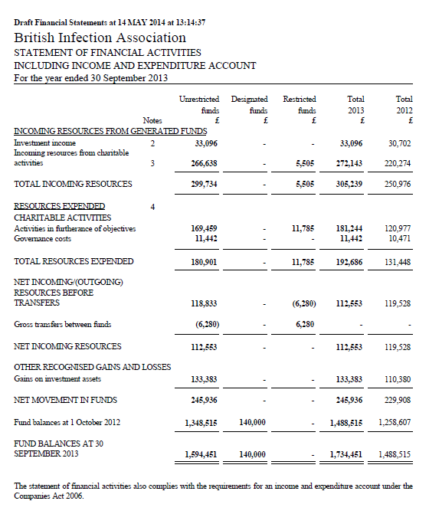
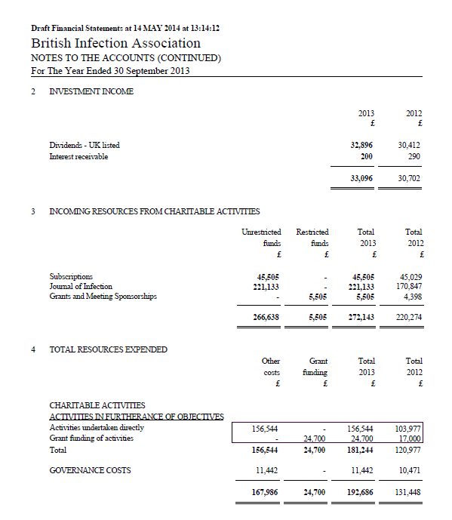
********************************************************

Honorary Secretary’s Report

The year saw changes to membership of Council.
Nominations were opened in April 2013 for the posts of:
Vice-President
Meetings Secretary
Clinical Services Secretary (Infectious Diseases)
Membership Secretary
Guidelines Secretary
Communications Secretary
Secretary for associate members
Multiple nominations were received for two posts and elections were held.
Vice President Dr Martin Wiselska elected
CSC (ID) Dr Bridget Atkins elected
One nomination for each of the following posts was received and these nominees were elected unopposed;
Meetings Secretary Professor Steve Green
Membership Secretary Dr David Partridge
Guidelines Secretary Dr Peter Cowling
Communications Secretary Dr Kumara Dharmasena
No nominations were received for the post of Secretary for Associate Members
Council decided to secure external administrative support to support the smooth running of the Association’s affairs. After an open invitation, Hartley Taylor Medical Communications Ltd was appointed for a 3-year period.

AJ Mifsud
Interim Hon Sec

Contact details

Postal Address:
British Infection Association
C/o Hartley Taylor Ltd
Suite GC
Caledonian House
Tatton Street
Knutsford
WA16 6AG

Telephone:
Please contact Head office on 01565 632982

Email:
bia@hartleytaylor.co.uk

Council members contact details:
President, Dr Peter Moss, president@britishinfection.org
Vice President, Dr Martin Wiselka, vicepresident@britishinfection.org
Honorary Secretary, Dr Albert Mifsud, secretary@britishinfection.org
Honorary Treasurer, Dr Stephen Barrett, treasurer@britishinfection.org
Meetings Secretary, Professor Steve Green, meetings@britishinfection.org
Membership Secretary, Dr David Partridge, membership@britishinfection.org
Clinical Services (ID), Dr Bridget Atkins, clinicalservicesid@britishinfection.org
Clinical Services (Micro & Virology), Dr Tony Elston, clinicalservicesmv@britishinfection.org
Guidelines Secretary, Dr Peter Cowling, guidelines@britishinfection.org
Communications Secretary, Dr Kumara Dharmasena, communications@britishinfection.org
Manpower & Training Secretary, Dr Albert Mifsud, manpowertraining@britishinfection.org
Scientific & Research Secretary, Drs Martin Llewelyn and Melanie Newport, scientificresearch@britishinfection.org
Trainee (Meetings) Secretary, Dr Fiona McGill, traineemeetings@britishinfection.org
Trainee (Professional Affairs) Secretary, Dr Thushan De Silva, traineeprofaffairs@britishinfection.org
Trainee (Communications) Secretary, Dr David Partridge, trainee@britishinfection.org
Newsletter Editor, Dr Paul Collini, newsletter@britishinfection.org

