GNBs – Other Enterobacterales

“Hi everyone, welcome to the IDIOTS podcast, that’s Infectious Disease Insight Of Two Specialists, I’m Jame, that’s Callum, and we’re going to tell you everything you need to know about Infectious disease, Callum how you doing?”

GNB, Facultative Anaerobe, Nonsporing, Motile (NB: Not Klebsiella, Shigella, Tatumella)

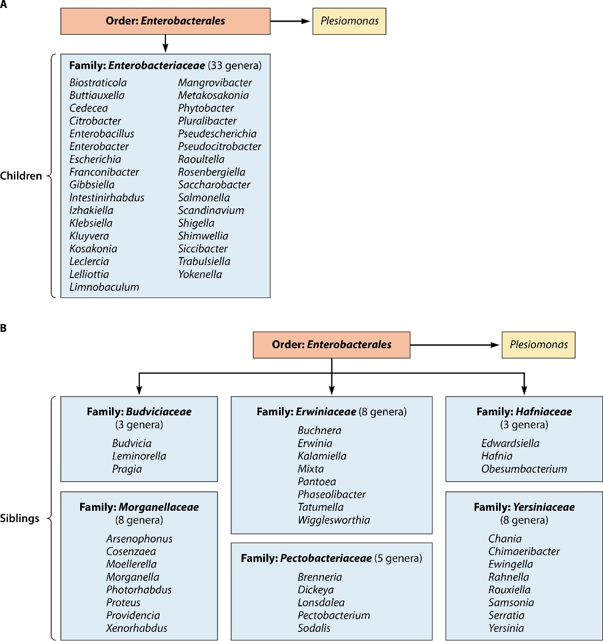
Enterobacterales (NLF in Red)
- Enterobacteriaceae
  - E.coli
  - Klebsiella
  - Enterobacter
  - Citrobacter
  - Raoultella
  - Klyuvera
  - Salmonella
  - Shigella
  - Plesiomonas
- Erwiniaceae
  - Pantoea
- Hafniaceae
  - Hafnia
- Morganellaceae
  - Morganella
  - Proteus
  - Providencia
- Yersiniaceae
  - Yersinia
  - Serratia

Lactose fermenting Enterobacterales

Basic ID if MALDI broken:

Spp | Urease | Indole
Citrobacter | + | +
Klebsiella | + | -
E.coli | - | +
Enterobacter  Serratia | - | -
All Oxidase negative

Genus | Spp (main) | Spp (No.) | Colony | Site | Causes | Notes
Citrobacter | Freundii  Koseri | 11 | Grey, smooth  Can be mucoid |  | UTI  Nosocomial  Koseri: NeoN Meningitis | N. polymicrobial sepsis
Enterobacter | Cloacae complex (6 species, cloacae et al) | 26 | Slight mucoid | GIT | Nosocomial  Neut sepsis  DFI | MDR
Hafnia | Alvei | 2 | Clear, big, convex  XLD: Red/pink |  |  | IND-, Nit+  Former Enterobacter
Klyuvera | Spp |  |  |  |  | R Penicillin / Cephalos
Pantoea | Agglomerans  Septica |  |  |  |  | Former Enterobacter
Serratia | Marcescens  Liquefaciens | 15 | Pink/clear | URT  Urinary | Nosocomial  -HAP  -UTI

Non-Lactose fermenting Enterobacterales

Basic ID if MALDI broken:

Ox pos:
- Plesiomonas shigelloides
- Glucose nonfermenter (Pseudomonas, Burkholderia)

Ox neg:
Spp | Urease | Indole
Morganella  Providencia rettgeri  Proteus spp. | + | +
Proteus mirabilis  Yersinia | + | -
Providencia spp. | - | +
Shigella | - | v
Salmonella | - | -

Genus | Spp (main) | Spp (No.) | Colony | Site | Causes | Notes
Plesiomonas | Shigelloides | 1 | Grey, convex  Beta-haemolytic | Soil, Freshwater | Diarrhoea
Morganella | morganii | 2 | Grey, convex
Proteus | Mirabilis  Vulgaris | 4 | Swarm (Mirabilis, Vulgaris)  Maconkey: Clear, flat | GIT | Mirabilis: UTI  Nosocomial: Other | Nitrofurantoin Res  Swarming is 2ry being flagellated  Urease Urine pH increases (ammonia formation) struvite stone precipitation
Providencia | Stuartii  Rettgeri | 8 | Clear, flat

Miscellaneous lists

Chromosomal AmpC Carriers (high-risk): HECK YES
- Hafnia alvei
- Enterobacter cloacae
- Citrobacter freundii
- Klebsiella aerogenes
- Yersinia enterocolitica
Lower Risk Chromosomal AMPC: Vulgar Proteus Store AMPC
- Vulgaris Proteus
- Serratia
- Acinetobacter
- Morganella
- Providencia

Intrinsic Colistin Resistance:
- Burkholderia cepacia (Nonfermenter)
- Proteus
- Providencia
- Serratia

Biochemical mimics of Salmonella (also can group)
- Hafnia
- Morganella
- Proteus

Cat 3 organisms:
- Salmonella typhi/paratyphi
- Shigella dysenteriae type 1
- E.coli O157
- Yersinia Pestis

References

SMI ID 16: identification of Enterobacteriaceae
https://www.gov.uk/government/publications/smi-id-16-identification-of-enterobacteriaceae

Janda JM, Abbott SL. 2021. The changing face of the family Enterobacteriaceae (order: “Enterobacterales”): new members, taxonomic issues, geographic expansion, and new diseases and disease syndromes. Clin Microbiol Rev 34:e00174-20.
https://doi.org/10.1128/CMR.00174-20

