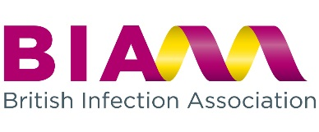

British Infection Association
Hartley Taylor Ltd
Caledonian House
Tatton Street
Knutsford
Cheshire
WA16 6AG
September 2017

Subject: BIA Endorsement – Position statement

BIA strive to enhance and improve the prevention, management, and control of infection and to improve professional representation on national bodies formulating policy about training, continuing professional development and delivering health care in the field of infection

In order to endorse meetings, events and publications, BIA would look for requesting bodies to be in line with and supporting the aims of the association as indicated below:

To develop and provide education and training in infection for all and in particular training grades.

To foster excellence in all aspects of infection-related research.

To support all aspects of communication between different branches of infection and to work towards the development of an integrated voice for infection specialists.

Requestors should be non-profit, professional bodies or organisations.

The President,
British Infection Association.


http://www.britishinfection.org/
Hartley Taylor Medical Communications Ltd
Suite GC, Caledonian House, Tatton Street, Knutsford, WA16 6AG
Tel: 01565 632 982 E-mail: BIA@hartleytaylor.co.uk Web: www.hartleytaylor.co.uk

